PROJECT REPORT OF CO-OP Project at Industry (Module-2)
ON
Multi-Vendor E-Commerce
Submitted in partial fulfilment of the requirements for the award of degree of

BACHELOR OF ENGINEERING
In
COMPUTER SCIENCE AND ENGINEERING

Submitted by: Supervised By:
Raghav Kakkar- 2210990698 Dr. Anshu Singla
Mehak Sharma- 2210991919
Neharika- 2210990605


DEPARTMENT OF COMPUTER SCIENCE AND ENGINEERING

CHITKARA UNIVERSITY INSTITUTE OF ENGINEERING AND TECHNOLOGY
CHITKARA UNIVERSITY, PUNJAB, INDIA

CONTENTS

S.No. | Title | Page No.
 | Acknowledgement | iv
 | List of Figures and Tables | v
 | Abstract
1 | Introduction | 1
2 | Methodology
3 | Tools and Technologies
4 | Implementation
5 | Major Findings/Outcomes/Output/Results
6 | Conclusion and Future Scope
 | References
 | Appendices

DECLARATION

I hereby certify that the work which is being presented in the project report entitled “Multi-Vendor E-Commerce” in partial fulfilment of requirement for the award of the degree of Bachelor of Engineering (Computer Science and Engineering) submitted in the department of Computer Science and Engineering at Chitkara University Institute of Engineering and Technology, Chitkara University, Punjab, India, is an authentic record of my own work carried out under the supervision of Dr. Anshu Singla. The matter presented in this project report has not been submitted in any other university/institute for the award of any degree.

Place: Rajpura Raghav Kakkar- 2210990698 Mehak Sharma- 2210991919 Neharika- 2210990605

Date: 30 Apr 2026

This is to certify that the above statement made by the candidate is correct to the best of my knowledge and belief.

Dr. Anshu Singla
Professor | Head-Academic Delivery

Department of Computer Science and Engineering
Chitkara University Institute of Engineering and Technology,
Chitkara University, Punjab, India

ACKNOWLEDGEMENT
We would like to express our sincere gratitude to our mentor, Dr. Anshu Singla, Department of Computer Science and Engineering, Chitkara University Institute of Engineering and Technology, for her valuable guidance, continuous support, and encouragement throughout the development of this project.
We are also thankful to Chitkara University, Punjab, for providing us with the necessary resources, facilities, and academic environment required for the successful completion of this project.
We would also like to thank all the faculty members, friends, and team members whose cooperation and suggestions helped us in completing this work successfully.
Finally, we express our gratitude to our families for their constant motivation and support throughout the project duration.

Introduction
1.1 Background
With the rapid growth of online shopping and digital businesses, e-commerce platforms have become an essential part of modern trade. However, many local artisans and handmade product creators still face challenges in reaching wider audiences due to lack of technical knowledge and access to affordable online marketplaces. Existing platforms often charge high commissions or do not specifically focus on handmade products.
The Handmade Multi-Vendor E-Commerce Platform was developed to bridge this gap by creating a dedicated online marketplace where multiple vendors can sell handmade products directly to customers. The platform provides a user-friendly interface for both vendors and buyers while ensuring efficient product management and secure transactions.

1.2 Problem Statement
Traditional handmade product sellers face several issues such as:
- Limited market reach
- Lack of digital presence
- Difficulty in managing orders and inventory
- High dependency on physical stores and exhibitions
- Absence of a centralized platform for handmade products
The project aims to solve these problems by providing an online system where vendors can independently manage their products and customers can conveniently purchase handmade items.

1.3 Objectives
The main objectives of the project are:
- To develop a multi-vendor e-commerce platform for handmade products
- To provide separate dashboards for admin, vendors, and customers
- To implement secure authentication and authorization
- To simplify product listing and order management
- To enable customers to browse and purchase handmade products online
- To promote small-scale businesses and artisans

1.4 Scope of the Project
- The system can be used by:
- Handmade product sellers
- Local artisans
- Customers interested in unique handmade products
- Administrators managing the platform
The project mainly focuses on:
- Vendor registration and management
- Product management
- Shopping cart functionality
- Order placement and tracking
- User authentication and authorization
Methodology

The project followed the Software Development Life Cycle (SDLC) methodology for systematic development and implementation.

2.1 Requirement Analysis
Requirements were collected by studying existing e-commerce systems and identifying the needs of vendors and customers. Functional and non-functional requirements were documented.

Functional Requirements
- User registration and login
- Vendor product management
- Product search and filtering
- Cart and checkout functionality
- Order management
- Admin panel

Non-Functional Requirements
- Security
- Scalability
- User-friendly interface
- Fast response time
- Database reliability

2.2 System Design
The system architecture was designed using a client-server model.
Modules
- Admin Module
- Vendor Module
- Customer Module
- Product Management Module
- Order Management Module
- Payment Module

2.3 Database Design
The database was designed using relational tables for:
- Users
- Vendors
- Products
- Orders
- Categories
- Payments
Relationships between tables were established using primary and foreign keys.

2.4 Development Process
The platform was developed in phases:
- Frontend Design
- Backend Development
- Database Integration
- API Development
- Testing and Debugging
- Deployment

2.5 Testing
Different testing methods were used:
- Unit Testing
- Integration Testing
- System Testing
- User Acceptance Testing

Tools and Technologies

3.1 Frontend Technologies
- HTML5
- CSS3
- JavaScript
- Bootstrap
- React.js

3.2 Backend Technologies
- Node.js
- Express.js

3.3 Database
MongoDB

3.4 Development Tools
- Visual Studio Code
- Postman
- Git and GitHub

3.5 Hosting and Deployment
Render / Vercel / Netlify / Localhost

3.6 Other Technologies
- REST APIs
- JWT Authentication

Implementation

4.1 User Authentication
The system implements secure user authentication using login and registration functionality. JWT tokens and encrypted passwords ensure secure access.

4.2 Vendor Dashboard
Vendors can:
- Add products
- Update product details
- Delete products
- View orders
- Manage inventory

4.3 Customer Features
Customers can:
- Browse products
- Search products
- Add items to cart
- Place orders
- Track orders

4.4 Admin Features
The admin manages:
- Vendors
- Products
- Users
- Orders
- Reports and analytics

4.5 Product Management
Each product contains:
- Product name
- Description
- Price
- Images
- Category
- Stock availability

4.6 Cart and Checkout
The shopping cart allows users to:
- Add/remove products
- Update quantities
- Calculate total amount
- Proceed to checkout

4.7 Responsive Design
The website is responsive and accessible on:
- Desktop
- Tablet
- Mobile devices

Major Findings/Outcomes/Output/Results

5.1 Major Findings
- Multi-vendor architecture simplifies seller management.
- Handmade sellers benefit from online visibility.
- Customers prefer categorized product browsing and secure checkout.

5.2 Outcomes
- Successfully developed a functional e-commerce platform.
- Enabled multiple vendors to sell products independently.
- Improved accessibility for handmade product businesses.

5.3 Results
- Secure authentication and role-based access implemented.
- Efficient product and order management achieved.
- Responsive UI improved user experience.
- Database handled product and order operations effectively.

5.4 Advantages of the System
- Easy to use
- Scalable architecture
- Centralized management
- Better reach for artisans
- Time-saving for vendors and customers

Conclusion and Future Scope

The Handmade Multi-Vendor E-Commerce Platform successfully fulfils the objective of creating an online marketplace for handmade product sellers. The system provides an efficient and secure environment where vendors can manage products and customers can purchase products conveniently. The project helped in understanding real-world implementation of full-stack development, database management, authentication systems, and e-commerce workflows.
The platform promotes digital business opportunities for local artisans and demonstrates the practical application of software engineering concepts learned during the B.E/B.Tech curriculum.

6.1 Future Scope
Future enhancements can include:
- AI-based product recommendations
- Live chat between buyers and vendors
- Mobile application development
- Advanced analytics dashboard
- Multi-language support
- Digital wallet integration
- Review and rating system
- Delivery tracking using GPS
- Payment Gateway Integration
- Machine learning for customer behaviour analysis

References

- Ian Sommerville, Software Engineering, Pearson Education.
- Efraim Turban, Electronic Commerce: A Managerial Perspective, Pearson.
- MongoDB Official Documentation.
- Node.js Official Documentation.
- Express.js Documentation.
- React.js Documentation.
- MDN Web Docs for HTML, CSS, and JavaScript.
- REST API Design Best Practices.

Appendices

Appendix A – Screenshots
Home Page



Login Page

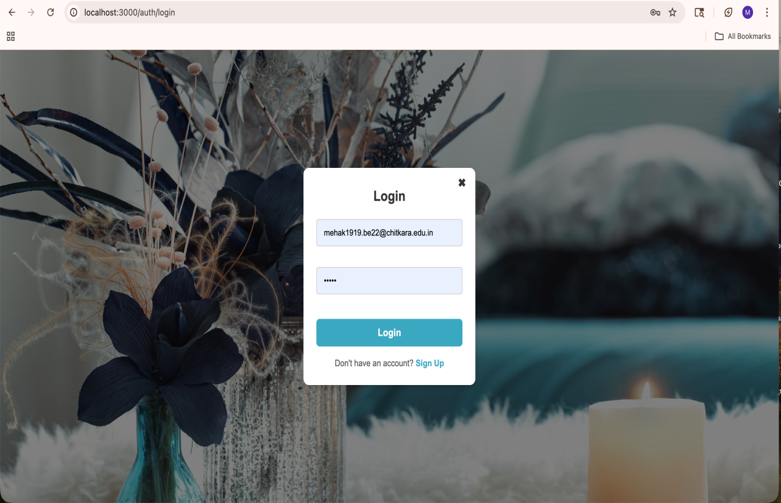

Vendor Dashboard

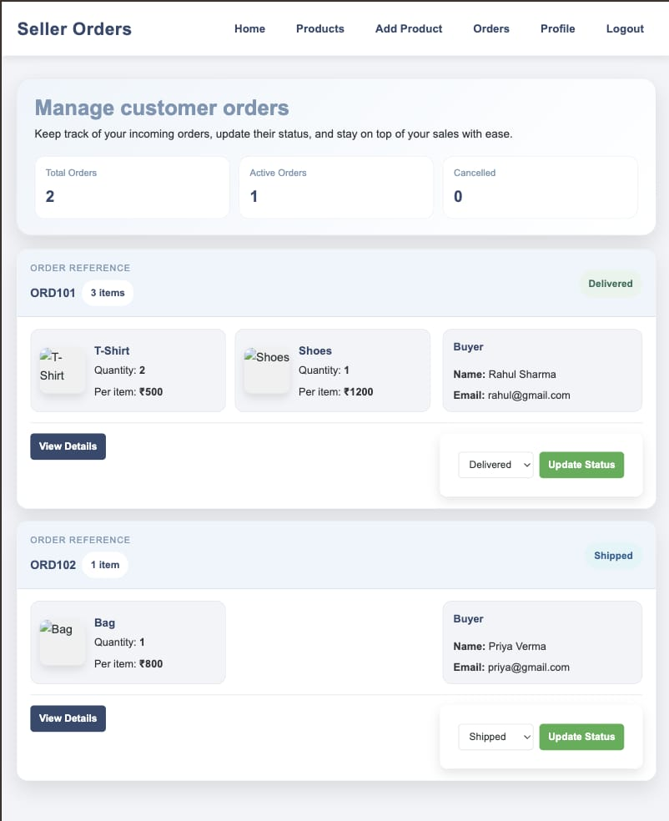

Product Listing Page

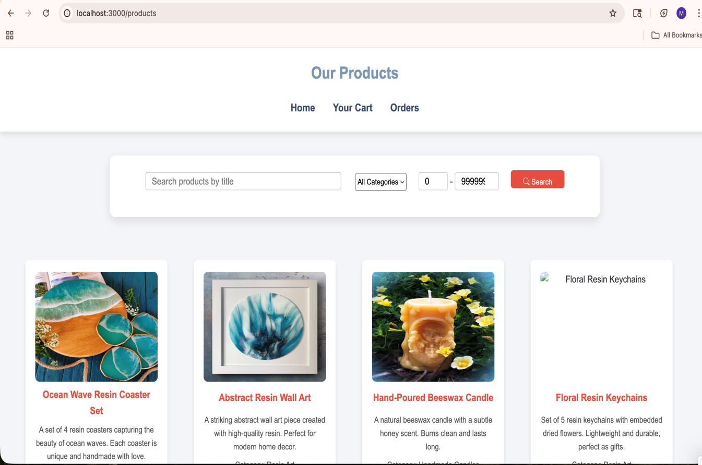

Cart/checkout Page

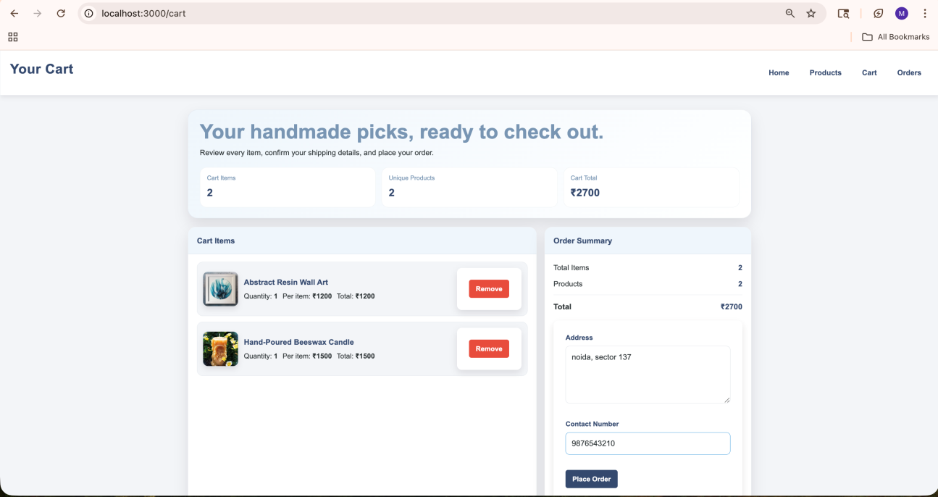

Appendix B – Source Code
Important code snippets for:
- Authentication / API routes

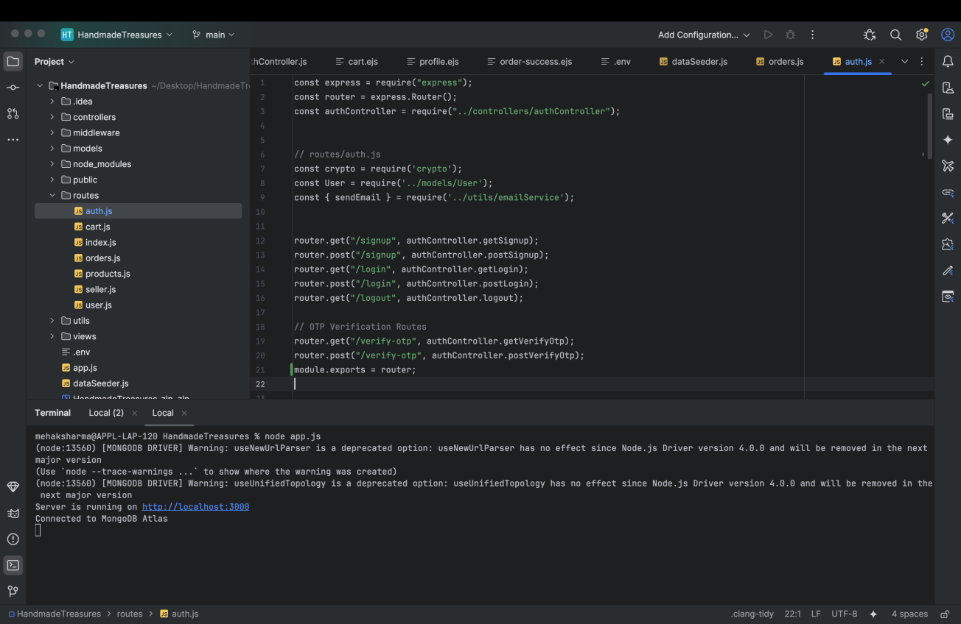

Product management

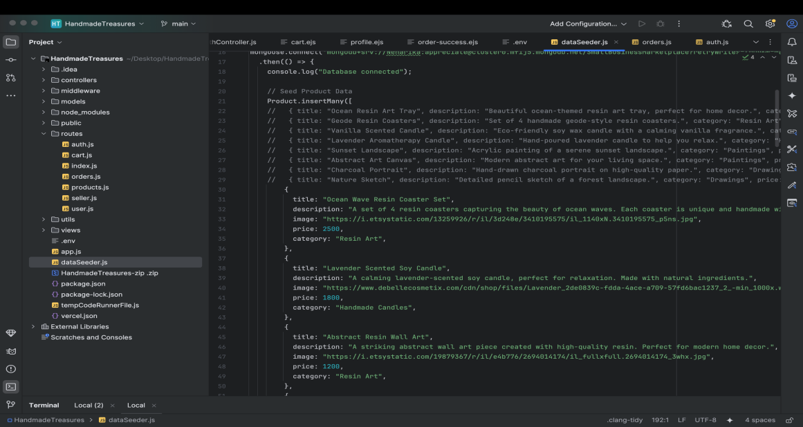

Appendix C – User Manual
Steps to Use the System
- Register/Login
- Browse products
- Add products to cart
- Place order
- Vendor manages products/orders
- Admin monitors system activities

